PGP Signed Message April 2017
On April 29 2017, new user came to #cicadasolvers IRC channel and notified us that he found new PGP signed message from cicada 3301.
- https://pastebin.com/yEiTHhvF

PGP-Signed Message
-----BEGIN PGP SIGNED MESSAGE-----
Hash: SHA512

Beware false paths. Always verify PGP signature from 7A35090F.

3301

-----BEGIN PGP SIGNATURE-----
Version: CicadaPG v.3301

iQIcBAEBCgAGBQJY5CrwAAoJEBgfAeV6NQkPFvMQAJa3W1K1gFcxFPk90fMFFKKx
oEd7wt26sMYE+FIQmaiC/4Eswmys52+joTUft4oSfHuxT79gg84EhSPSfyn4IpPD
aJivM4DAbh456bTq3Jk2ZUw97fTBLAHLPQFr/2sY6bmhncTHlx/hRUp2DKXcBccI
Zxl/0SuBiEAfFZuIW3hOS7gnoT409z9f7yKsrw+WrLjKiqziOle5Ck7u+EBJn75y
XyKEtRmzaMt/OvQGUV2WNErqZgnoq54/WZwTvlglIeTrK9t8q5KE80ybWthbdLpK
qtaIgPNN/mvX12Xbnhr6dqN1s7VHOZvjLzFu7j/9RrT90XHHTWo9P6GfNTzJkIWC
X+pakY2y+QJXcZhGk3Y7asWX/GGOvbhWnlHIpVsESK2JH5e2YFKusjyW2wTzaNQ6
aBSC+3QwxYVVSsETXR8cC4AaCueRmhmOOGC7gDYFLyKroEFbX4Ii9TllDV6z67Os
hFE3fhGDcoGdi4Hcs4mFUIgGE1TeD9XpogMSi2uXiZylUEaOKsg4spzuiuqI+YLi
8JqcuZ6rQVJ4j1MH95uGuwFzdIIupFLXAZ4NGLz+2Lia+nmq5e08FjVZ+0zb8cnw
17rLIBMwEgEyu2r5pq4ObToGuWvRIcaFOe7bhBNm9ZYR1DUVzD+hJ4XQa5jhi23C
s2bdlE5mbHOLUuNuOm50
=6zQ2
-----END PGP SIGNATURE-----

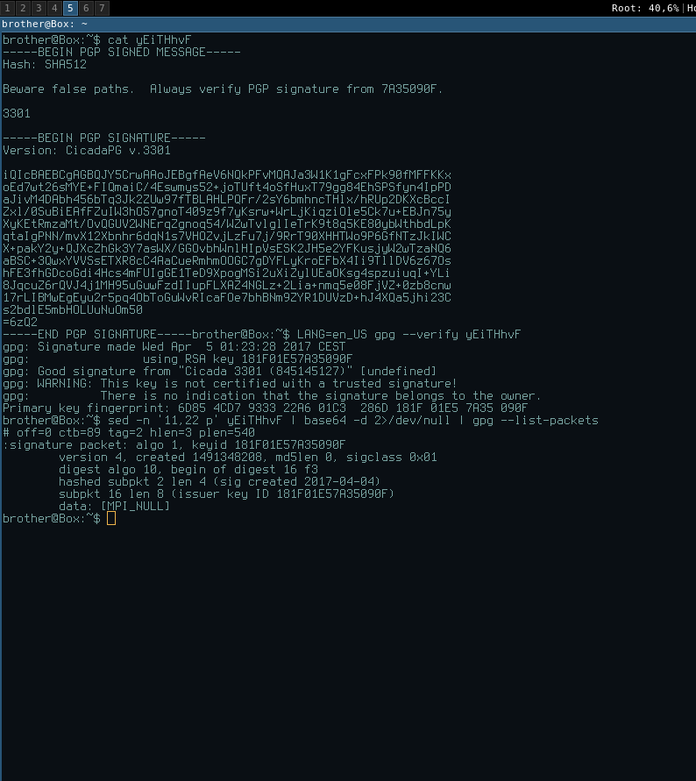
Message is signed with 0x7A35090F key. Date of signature is: Signed on 2017-04-04 23:23 GMT

More verifications:
- prntscr,
- imgur,
- cubeupload
At time #cicadasolvers users opened link, pastebin had 113 views.
According to google cache on April on 6 Apr 2017 11:46:25 GMT page had 72 views. prntscr.com, archive.fo, webcache.google
Here is how user found it:
<psilynt1> I was looking for the last pgp encrypted message from cicada (you know
the old one linked from twitter that said to verify with pgp)

<psilynt1> searched for

<psilynt1> searched for '7A35090F' on pastebin, sorted by date and there it was...
I thought it was the same, validated it, realized that WASN'T the same, realized
the pastebin date and brotherbin caught me posting it in a discord.

<psilynt1> I posted it in discord, here, then in defango's youtube chat.

